L1 Support

URL- <https://mcis.deltaiserve.net/>

1)Type the URL , enter the login credential and do the login

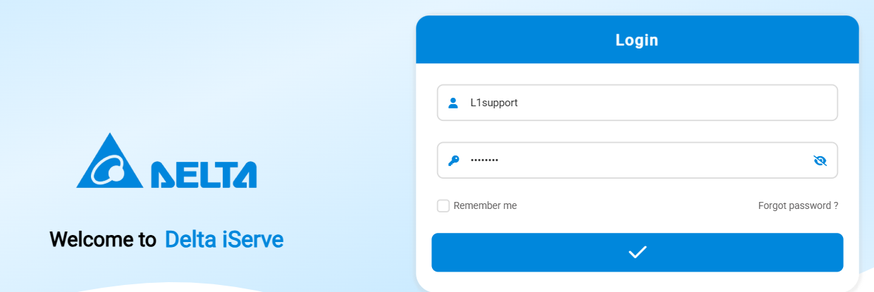

2) log the complaint in job register by clicking the add button,enter the product serial no and click the lense .System will fetch the model , group , sub group and customer details automatically.

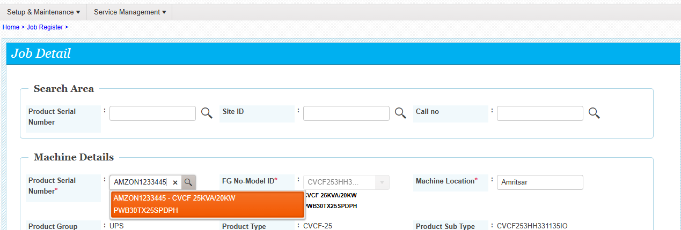

3) select the call type

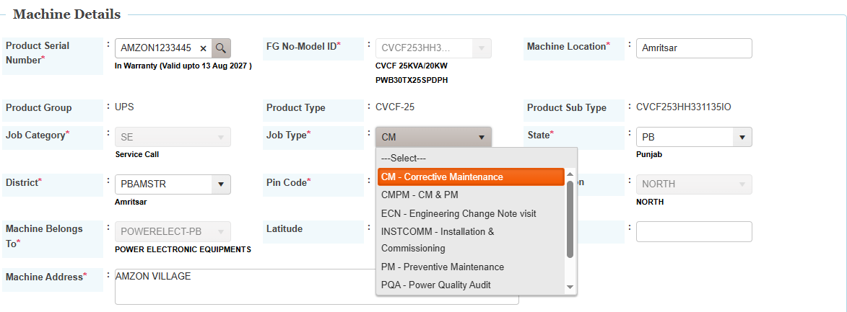

4) enter the contact details , select nature of problem , Job priority, and problem description and l1 remarks and then click on submit button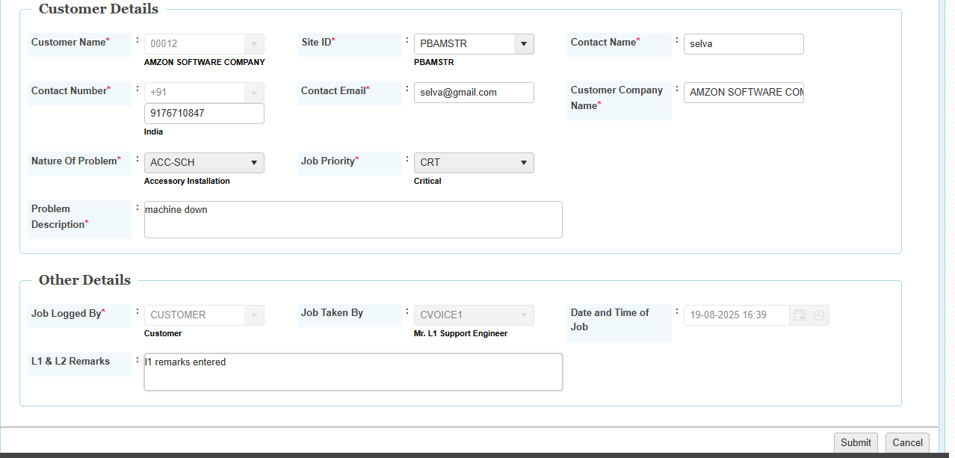

After submitting call will be generated

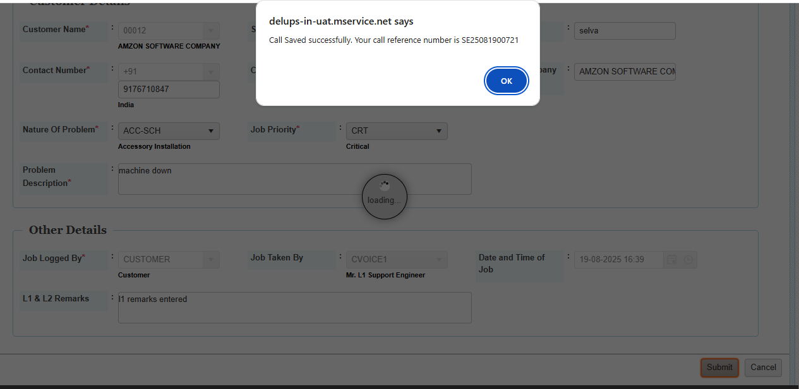Job assigned to L1 Support by the system ,

5) Go tto job register action and see the options available . now l1 can assign the job to l2 or assign to onsite support .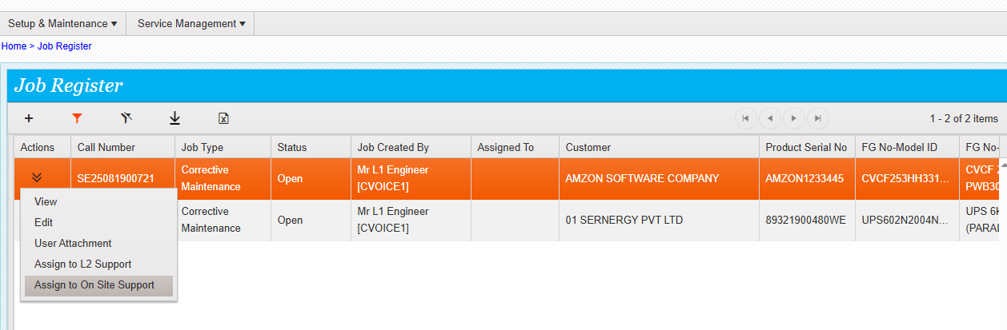

Assign to l2 support clicked / then system will show the l2 assignee list . l1 can select one l2 person from the dropdown and then submit , so that that call could be assigned to l2

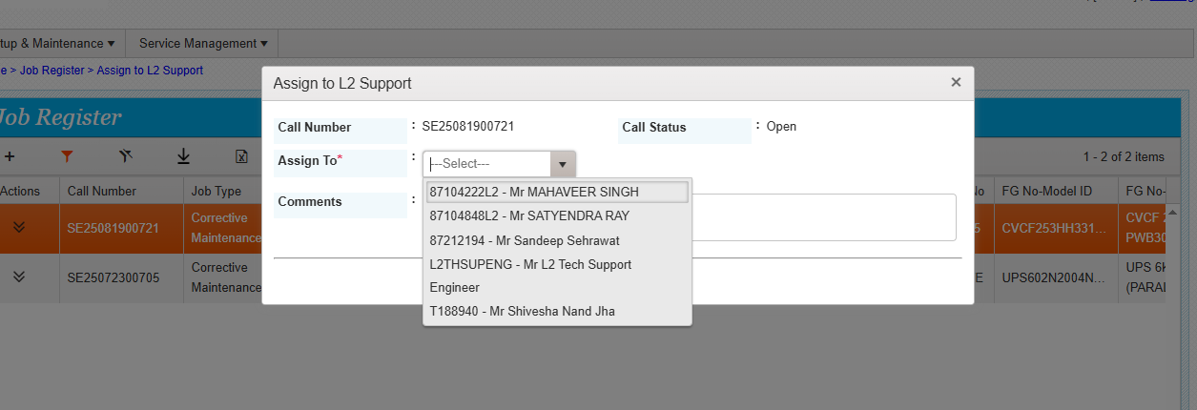

Assigned to onsite support clicked then system will show the machine belongs to details once submit button is clicked then the call will be assigned to the respective coordinator

